**Name:** ___ _____

**Lab time:** ___Friday 3pm____

**Due time: The same day with Lab time by midnight @11:59pm.**

*Submit to: [gemclassassist@gmail.com](mailto:gemclassassist@gmail.com)

*Subject format: Spring2020_CSc1301_Lab03_FirstName_LastName

*Please rename this file as “Lab03_FirstnameLastname”.

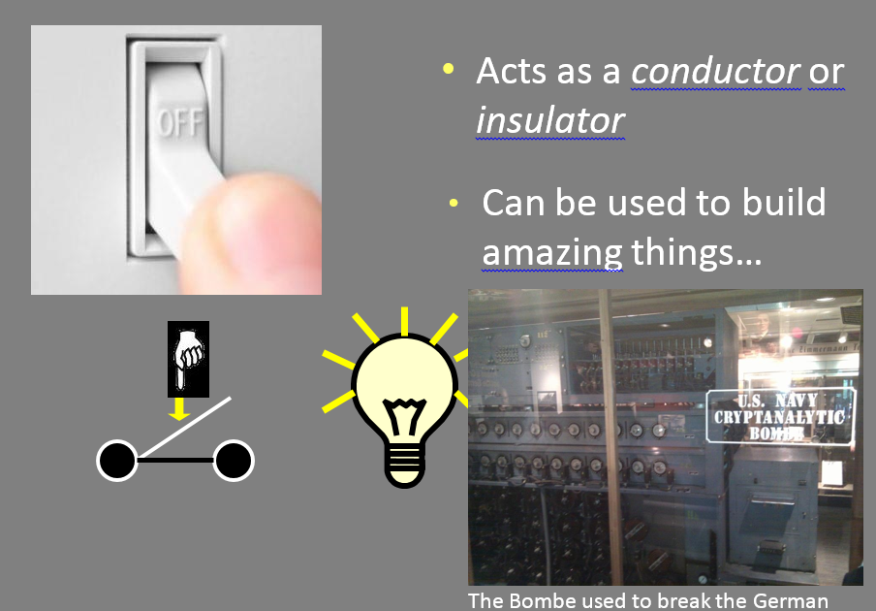

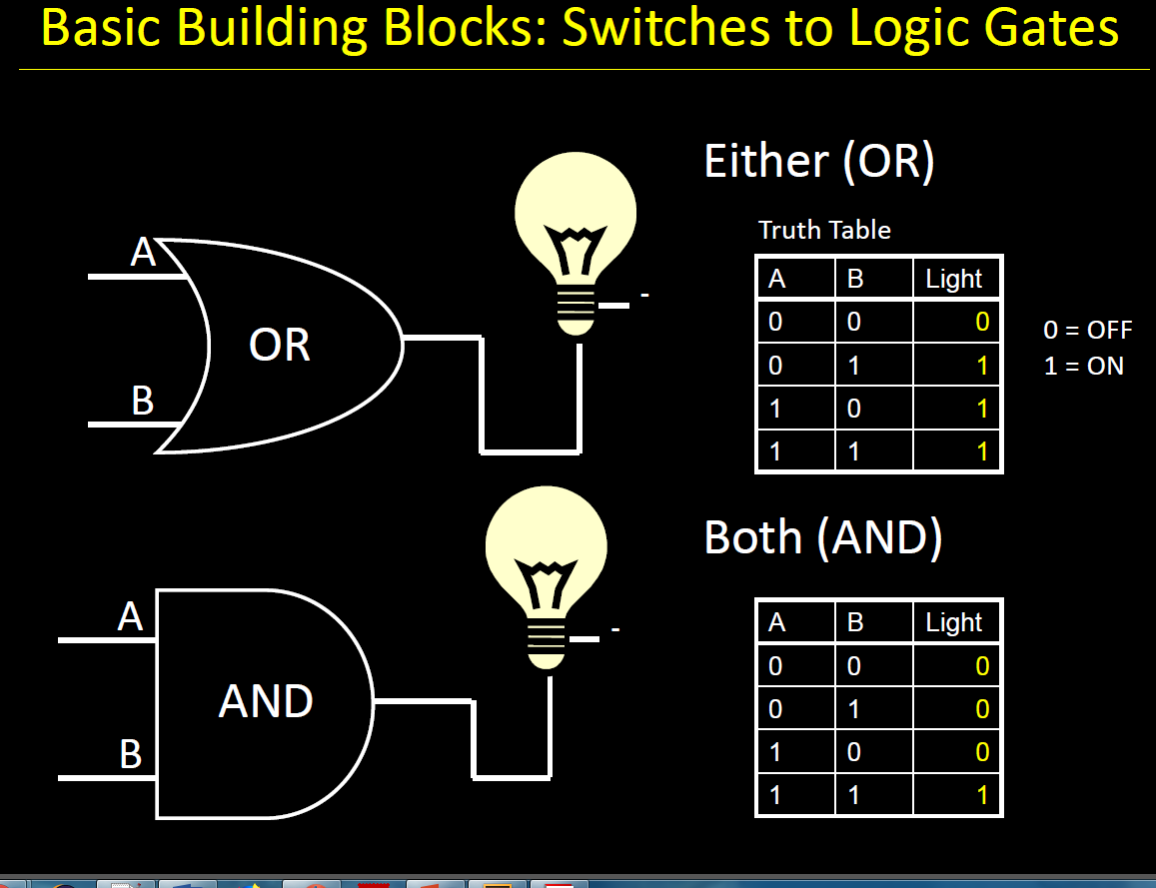

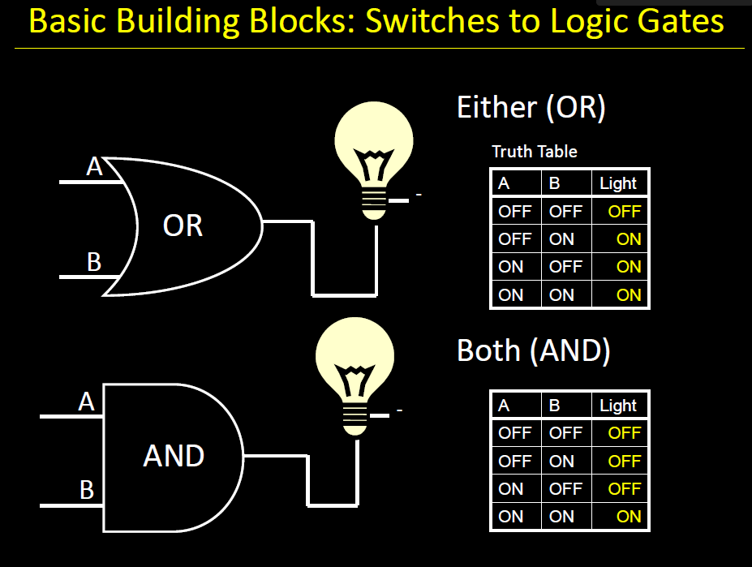

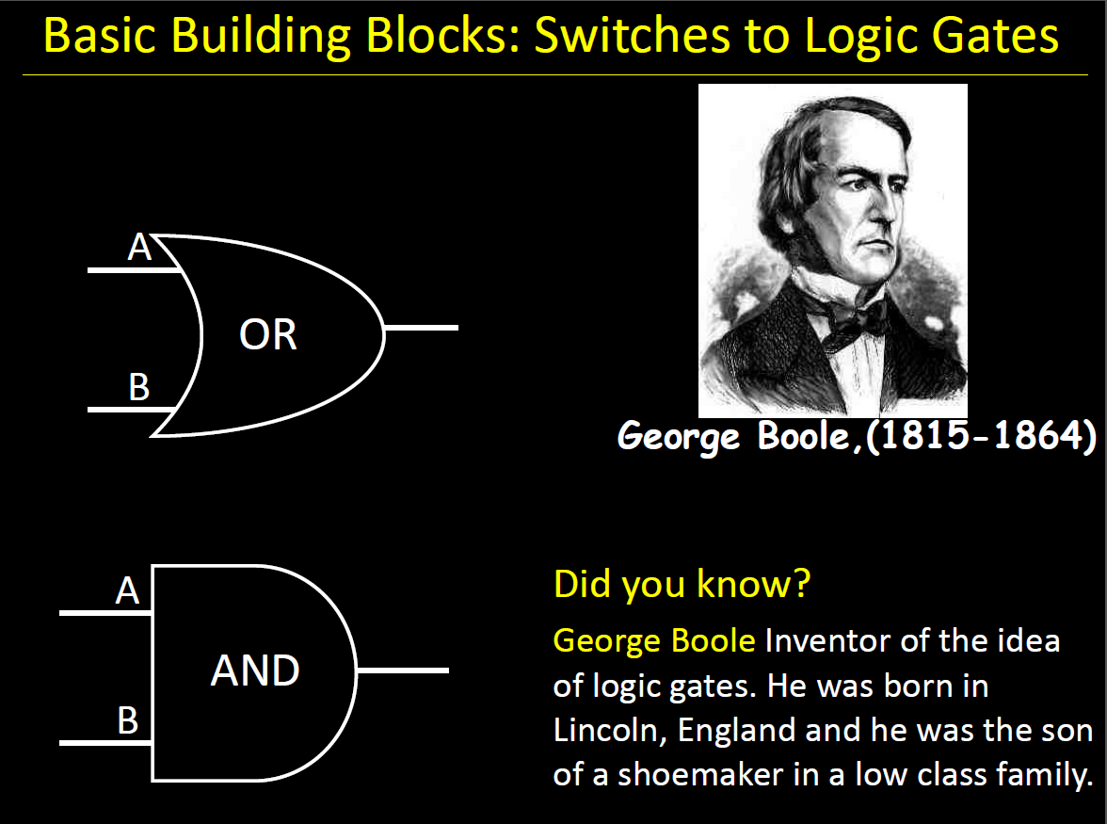

Takeaway

Binary (two symbols: true and false) is the basis of Logic Design

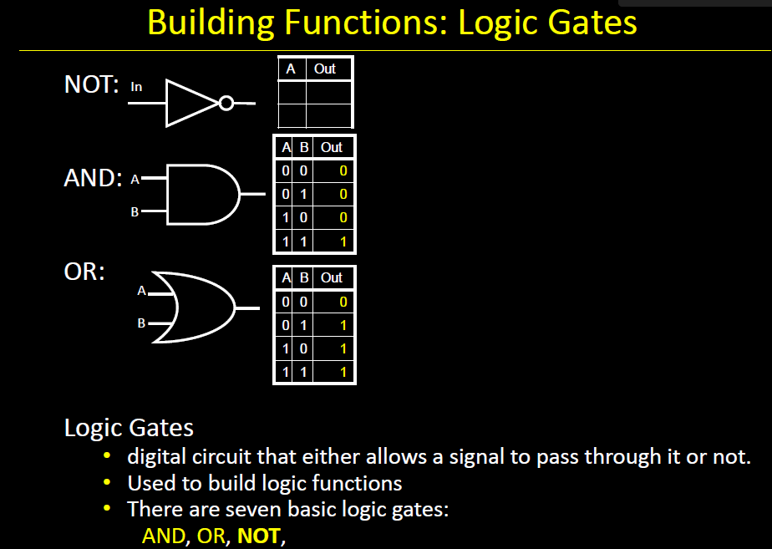

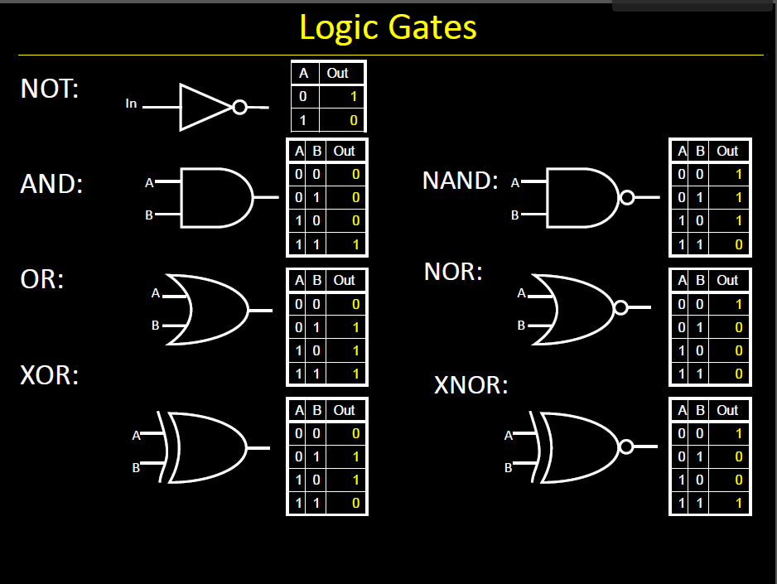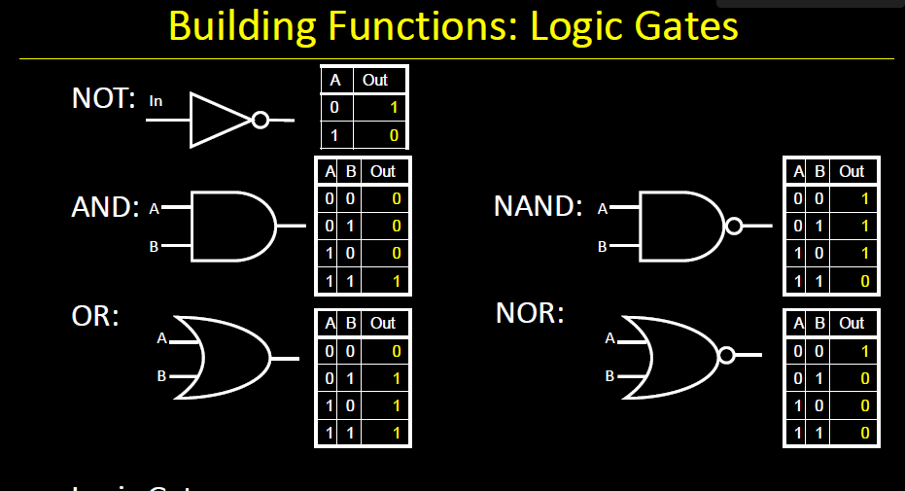

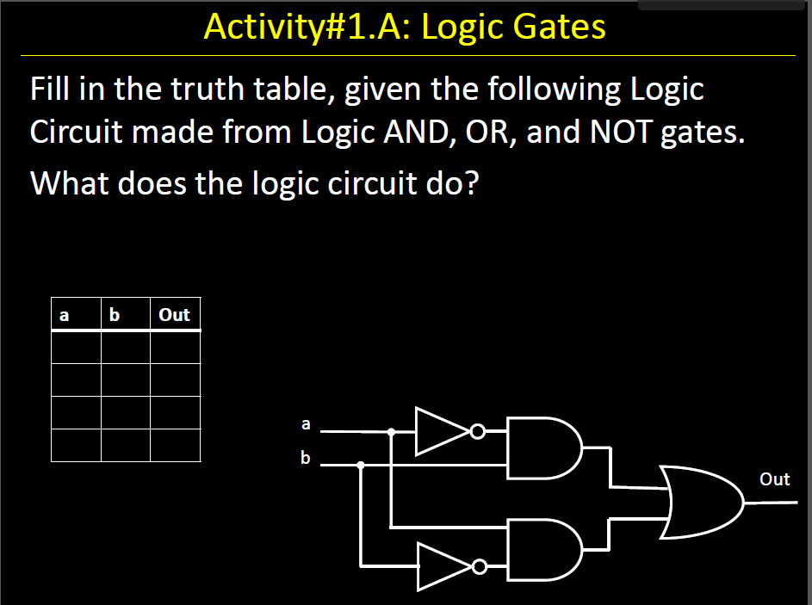

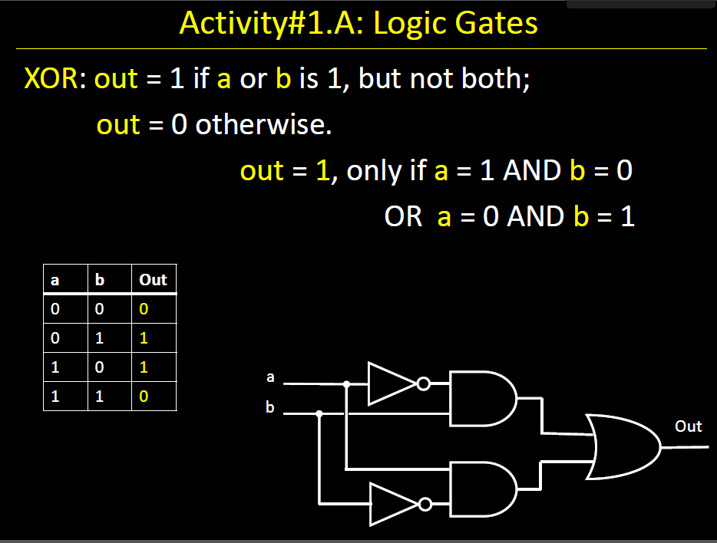

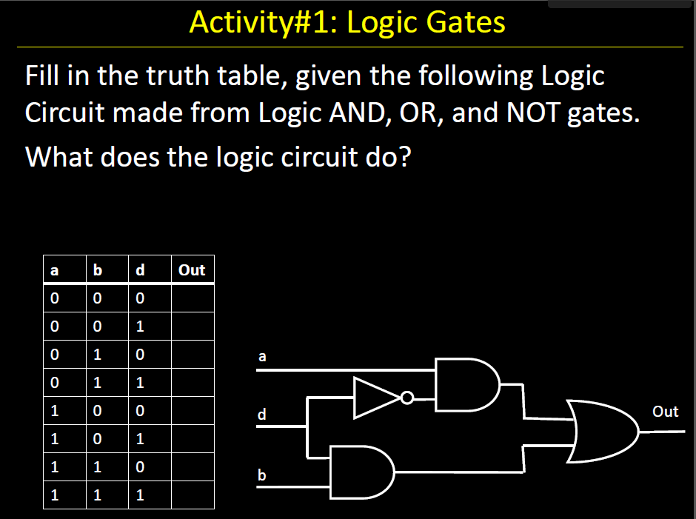

For Submission (Pick any 10 questions) and you can go over some of the question for example the ones that you have not assigned for submission. (How to Submit) The can had write/draw the solutions and download a PDF scanning app via phone take a picture upload the document to I-College

PART 2 –

**Logic Gates Exercises**

Build truth tables for following logic gates:

## Question #1



|  |  |  |
| --- | --- | --- |
| A | B | Y |
| 0 | 0 | 0 |
| 1 | 0 | 0 |
| 0 | 1 | 0 |
| 1 | 1 | 1 |

## Question #2



|  |  |  |
| --- | --- | --- |
| A | B | Y |
| 0 | 0 | 0 |
| 1 | 0 | 1 |
| 0 | 1 | 0 |
| 1 | 1 | 1 |

## Question #3



|  |  |
| --- | --- |
| A | Y |
| 0 | 1 |
| 1 | 0 |
|  |  |
|  |  |

For questions 4 to 18 Show the output for each circuits

## Question #4





|  |  |  |  |
| --- | --- | --- | --- |
| A | B | C | Y |
| 0 | 0 | 1 | 0 |
| 1 | 0 | 0 | 0 |
| 0 | 1 | 1 | 1 |
| 1 | 1 | 0 | 0 |

## Question #5





|  |  |  |  |  |
| --- | --- | --- | --- | --- |
| A | B | C | D | Y |
| 0 | 0 | 0 | 1 | 0 |
| 1 | 0 | 1 | 1 | 1 |
| 0 | 1 | 1 | 0 | 0 |
| 1 | 1 | 1 | 0 | 0 |

## Question #6





|  |  |  |  |  |  |
| --- | --- | --- | --- | --- | --- |
| A | B | C | D | E | Y |
| 0 | 0 | 1 | 0 | 0 | 0 |
| 1 | 0 | 0 | 0 | 0 | 0 |
| 0 | 1 | 1 | 1 | 0 | 1 |
| 1 | 1 | 0 | 0 | 1 | 1 |

## Question #7





|  |  |  |  |  |  |  |  |
| --- | --- | --- | --- | --- | --- | --- | --- |
| A | B | C | D | E | F | G | Y |
| 0 | 0 | 1 | 1 | 1 | 0 | 0 | 0 |
| 1 | 0 | 0 | 1 | 1 | 0 | 0 | 0 |
| 0 | 1 | 1 | 0 | 1 | 0 | 0 | 0 |
| 1 | 1 | 0 | 0 | 0 | 1 | 1 | 1 |

## Question #8



|  |  |  |
| --- | --- | --- |
| A | B | Y |
| 0 | 0 | 0 |
| 1 | 0 | 1 |
| 0 | 1 | 1 |
| 1 | 1 | 0 |

## Question #9





|  |  |  |  |  |  |
| --- | --- | --- | --- | --- | --- |
| A | B | C | D | E | Y |
| 0 | 0 | 0 | 1 | 0 | 0 |
| 0 | 0 | 1 | 1 | 0 | 1 |
| 1 | 0 | 0 | 1 | 1 | 1 |
| 1 | 0 | 1 | 1 | 1 | 0 |
| 0 | 1 | 0 | 0 | 0 | 0 |
| 0 | 1 | 1 | 0 | 0 | 1 |
| 1 | 1 | 0 | 0 | 0 | 0 |
| 1 | 1 | 1 | 0 | 0 | 1 |

## Question #10





|  |  |  |  |  |  |
| --- | --- | --- | --- | --- | --- |
| A | B | C | D | E | Y |
| 0 | 0 | 1 | 1 | 0 | 1 |
| 1 | 0 | 0 | 0 | 0 | 1 |
| 0 | 1 | 1 | 0 | 0 | 1 |
| 1 | 1 | 0 | 1 | 1 | 0 |

## Question #11





|  |  |  |  |  |
| --- | --- | --- | --- | --- |
| A | B | C | D | Y |
| 0 | 0 | 0 | 0 | 0 |
| 1 | 0 | 1 | 1 | 0 |
| 0 | 1 | 1 | 1 | 0 |
| 1 | 1 | 1 | 1 | 0 |

## Question #12



|  |  |  |
| --- | --- | --- |
| A | B | Y |
| 0 | 0 | 1 |
| 0 | 1 | 1 |
| 1 | 0 | 1 |
| 1 | 1 | 0 |

## Question #13





|  |  |  |  |  |  |  |
| --- | --- | --- | --- | --- | --- | --- |
| A | B | C | D | E | F | Y |
| 0 | 0 | 0 | 1 | 1 | 1 | 0 |
| 0 | 0 | 1 | 1 | 1 | 1 | 0 |
| 1 | 0 | 0 | 0 | 1 | 1 | 0 |
| 1 | 0 | 1 | 0 | 1 | 1 | 0 |
| 0 | 1 | 0 | 1 | 0 | 0 | 1 |
| 0 | 1 | 1 | 1 | 0 | 1 | 0 |
| 1 | 1 | 0 | 0 | 1 | 1 | 0 |
| 1 | 1 | 1 | 0 | 1 | 1 | 0 |

## Question #14

The figure below shows a logic circuit and its incomplete truth table. Complete the below truth table.

|  |  |  |  |
| --- | --- | --- | --- |
| **A** | **B** | **C** | **Q** |
| 0 | 0 | 0 | 1 |
| 0 | 1 | 1 | 0 |
| 1 | 0 | 1 | 0 |
| 1 | 1 | 1 | 0 |

A Q

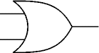

C

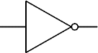

B

## Question #15

The figure below shows a logic circuit and its incomplete truth table. Complete its truth table.

|  |  |  |  |  |  |  |  |  |  |  |  |
| --- | --- | --- | --- | --- | --- | --- | --- | --- | --- | --- | --- |
| B    A    C    Q    D | |  |  |  |  |  | | --- | --- | --- | --- | --- | | 1 | 0 | 1 | 0 | 0 | | 1 | 1 | 1 | 1 | 1 | |

## Question #16

The figure below shows a logic circuit and its incomplete truth table. Complete the below truth table.

|  |  |  |  |  |  |  |  |  |  |  |  |  |  |  |  |  |  |  |  |  |  |  |  |  |  |  |
| --- | --- | --- | --- | --- | --- | --- | --- | --- | --- | --- | --- | --- | --- | --- | --- | --- | --- | --- | --- | --- | --- | --- | --- | --- | --- | --- |
| Q    A    B    C      D | |  |  |  |  |  | | --- | --- | --- | --- | --- | | **A** | **B** | **C** | **D** | **Q** | | 0 | 0 | 0 | 1 | 1 | | 0 | 1 | 1 | 0 | 1 | | 1 | 0 | 1 | 1 | 0 | | 1 | 1 | 1 | 0 | 1 | |

## Question #17

The figure below shows a logic circuit and its incomplete truth table. Complete the below truth table.

|  |  |  |  |  |  |  |  |  |  |  |  |  |  |  |  |  |  |  |  |  |  |  |  |  |  |  |
| --- | --- | --- | --- | --- | --- | --- | --- | --- | --- | --- | --- | --- | --- | --- | --- | --- | --- | --- | --- | --- | --- | --- | --- | --- | --- | --- |
| C    B    A    Q    D | |  |  |  |  |  | | --- | --- | --- | --- | --- | | **A** | **B** | **C** | **D** | **Q** | | 0 | 0 | 1 | 1 | 0 | | 0 | 1 | 0 | 0 | 1 | | 1 | 0 | 0 | 1 | 1 | | 1 | 1 | 0 | 0 | 1 | |

## Question #18

For the logic circuit below complete the truth table.

|  |  |  |  |  |  |  |  |  |  |  |  |  |  |  |  |  |  |  |  |  |  |  |  |  |  |  |
| --- | --- | --- | --- | --- | --- | --- | --- | --- | --- | --- | --- | --- | --- | --- | --- | --- | --- | --- | --- | --- | --- | --- | --- | --- | --- | --- |
|  | |  |  |  |  |  | | --- | --- | --- | --- | --- | | **A** | **B** | **C** | **D** | **Q** | | 0 | 0 | 1 | 1 | 0 | | 0 | 1 | 1 | 0 | 1 | | 1 | 0 | 0 | 1 | 1 | | 1 | 1 | 0 | 0 | 1 | |